**CS443 – Lab 5**

**Question 1:**

Use extended hashing technique to insert the employees in which their corresponding binary Empl_IDs are shown below. Assume you can have two employees per block. Show the depth of both global and local directories. The bits should be considered from left to right as shown in the lecture..

**00001, 10000, 10100, 00111, 11011, 11101, 10010, 01111, 10101**

**Note: d represents directory size. Starts sorting from left to right.**

**Note: Since there is going to be elements to be inserted, increase the directory size by 2.**

**Note: Bucket 10 is full, therefore d = 3, and will reupdate the extending hashing**

**CONTINUES ON NEXT PAGE**

**Question 2:**

Consider the following records of question 1: (Again Digits should be considered from left to right)

**00001, 10000, 10100, 00111, 11011, 11101, 10010, 01111, 10101**

Load the records into files using Dynamic Hashing Scheme. You can put two records per block. Show the directory at each step, and the global and local depths.

**Note: Sort the following digits by the front rather than the back.**

**Note: Since another element will be inserted, and the buckets are full, it must then expand as shown below.**

**Extend another since another element will be inserted and there is no space available inside the buckets.**

**CONTINUED**

**Extend another bucket since 01 has not been created.**

**Question 3:**

Insert the following into B+ tree of order **3**. Show your work step by step with proper illustration of pointers as shown in pages 47-54 in multi-way trees lecture

**90, 22, 27, 24, 28, 20, 51, 63, 8, 80, 15, 71, 35, 55**



**-------------------------------------------------------------------------------------------------------------------**



**Question 4:**

Insert the following into B_tree of order **3**. Show your work step by step with proper illustration of pointers as shown in pages 47-54 in multi-way trees lecture

**2, 99, 9, 71, 16, 11, 15, 13, 91, 92, 94**

**CONTINUED ON NEXT PAGE**

**Question 5:**

Consider the following B-tree.

a) Redraw the tree after deleting 14.

b) Again, redraw the tree after deleting 15.

c) Again, redraw the tree after deleting 25.

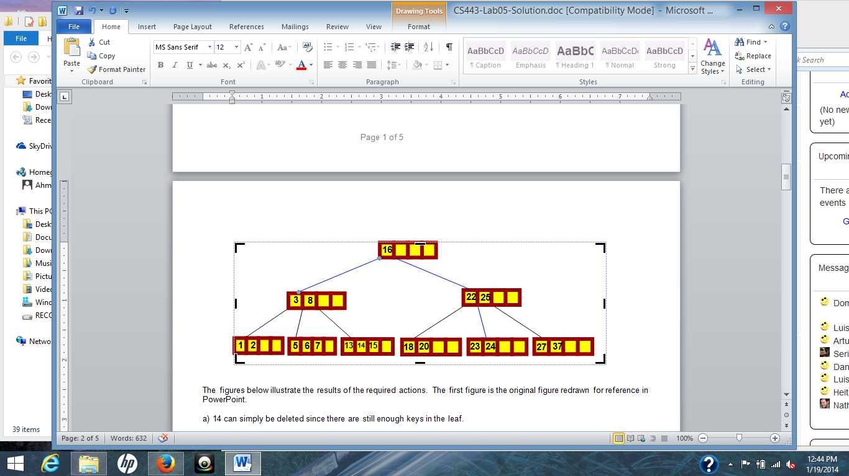

a. Delete 14

b. Delete 15

c. Delete 25

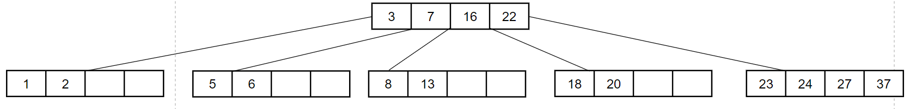

**Question 6:**

Consider the following B+ tree:

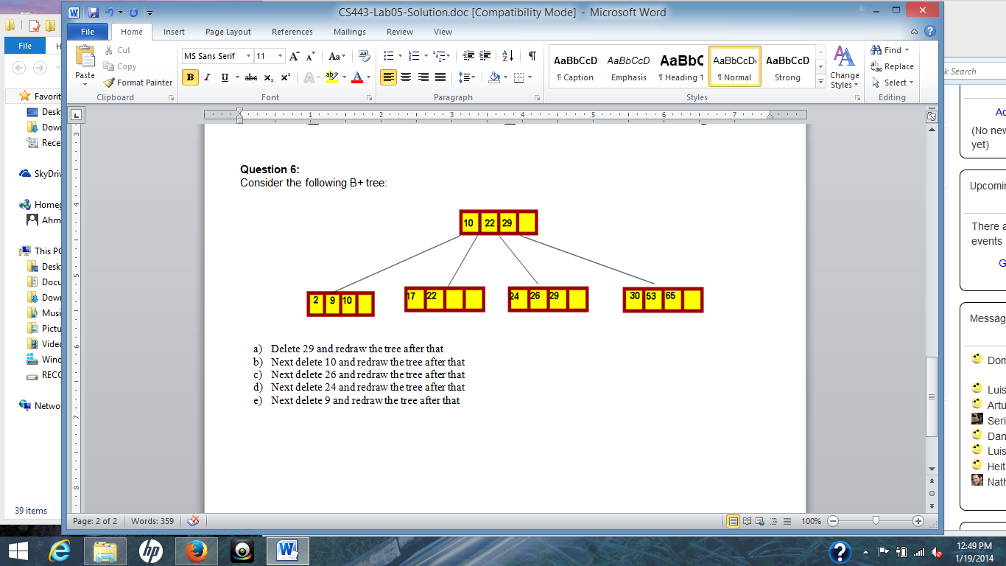

1. Delete 29 and redraw the tree after that

1. Next delete 10 and redraw the tree after that

1. Next delete 26 and redraw the tree after that

1. Next delete 24 and redraw the tree after that

1. Next delete 9 and redraw the tree after that

